

*****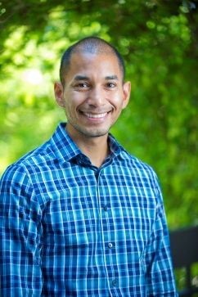*

**Apply by Monday, March 1, 2021 for:**

**The *Éxito!* Five-Day Summer Institute**

**June 7-11, 2021, in San Antonio, Texas**

**and for the**

***Éxito! Internships (June 2021-November 30, 2021)***

***Decide if a doctoral program is right for you; network with role models and peers; get tools to apply***

**Learn more at:**

[**www.exitotraining.** **org**](http://www.exitotraining.org)

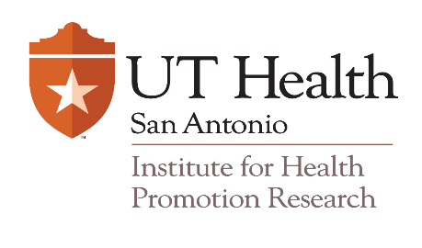

*Éxito!* is led by Dr. Amelie Ramirez of the Institute for Health Promotion Research at The University of Texas Health Science Center at San Antonio, thanks to an NCI grant (2R25CA134301-06), with support from the Cancer Therapy & Research Center, *Redes En Acción*, and the UCSF Helen Diller Family Comprehensive Cancer Center.

**What is *Éxito!?***

***The Éxito! Latino Cancer Research Leadership Training* program aims to encourage master’s-level students and master’s-level health professionals to pursue a doctoral degree and a career in Latino cancer health disparities research.**

***“ The institute played a very important role in guiding my next steps towards doctoral school by exposing me to other Latinos who have overcome barriers and life challenges; showing me various research interest and perspectives worth pursuing in a doctoral program; and providing me with a network of students and professionals willing to serve as mentors.” – Steven Lopez***

***“I encourage you to be part of a five-day journey that will change the***

***course of your life.”* – Mary Vanellys Diaz-Santana**